If you are being prevented from formatting your CLLE code the way you want to format it.

Windows / Preferences/ Remote Systems / Remote Systems LPEX Editor / IBM i Parsers / CL

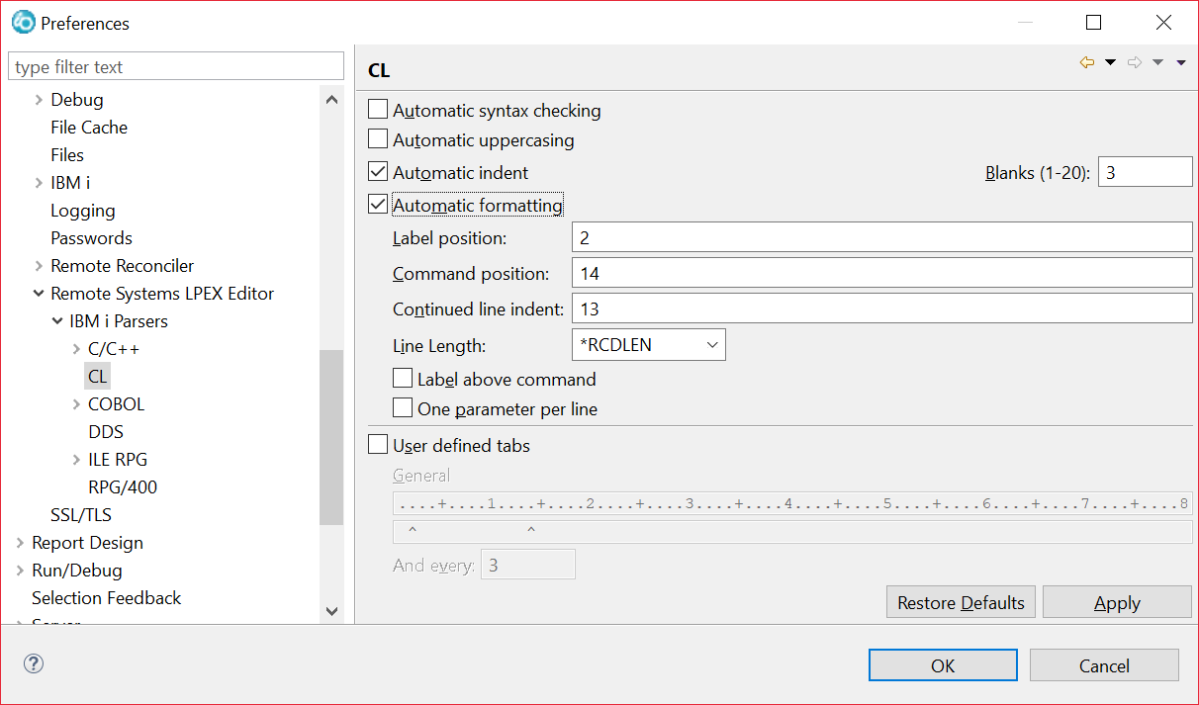

Get rid of Automatic indent and Automatic formatting

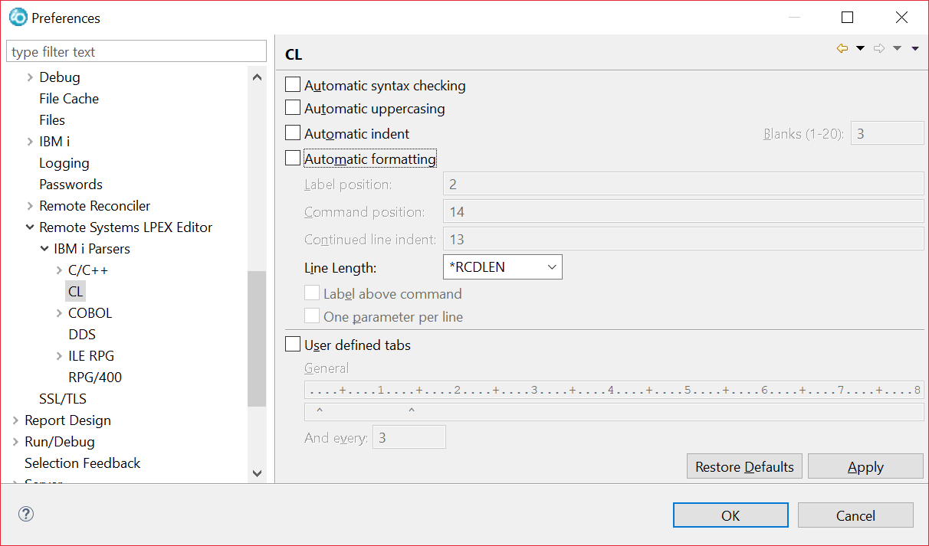

This only needs to be done once on your laptop or with your workspace. It has to be done everytime on a lab machine if you don’t bring your workspace to the lab.